Quadrotor Control Application

With Bluetooth Communication

Contents

Overview 1

Using the Application 2

Connecting with the Quadrotor 2

Communication 3

Logging Data 3

Matlab Connection 3

Appendix A: Setting Up Bluetooth 4

# Overview

This software was designed primarily as a means for communication with the quadrotor via Bluetooth. Through it the user can send messages to the quadrotor, read and record data sent from the quadrotor, and provides an interface to quickly plot the received data with Matlab.

# Using the Application

Use of the application is relatively straight forward. Figure 1 shows the interface of the application when first started.

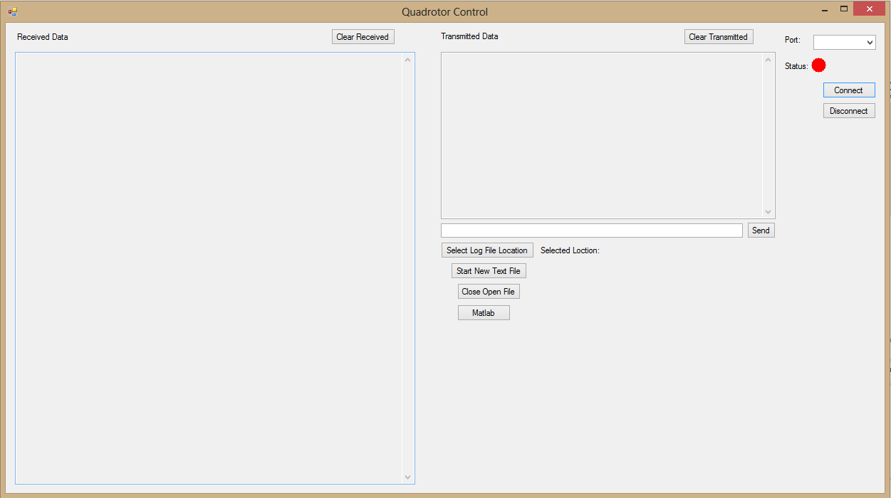

Figure : Interface

## Connecting with the Quadrotor

The first task when starting the application is to select the port on your computer that is connected to the Bluetooth modem from the drop-down list on the top right. (See Appendix A: Setting Up Bluetooth for more information). This list of ports is automatically populated when the application starts up so if you do not see the correct port listed, double check it is connected correctly and restart the application. After the correct port is selected pressing the ‘Connect’ button will send the connect message to the Bluetooth modem on the quadrotor and if the status light changes to green two-way communication can begin. The ‘Disconnect’ button will close the connection with the Bluetooth on the quadrotor. If there are issues in connecting to the quadrotor one possibility is that there is more than one laptop that is attempting to pair with it. There can only be one laptop that has a connection at a time. The quadrotor may need to be removed from any additional laptops in order for a new one to connect.

## Communication

Receiving transmitted data from the quadrotor is handled automatically by the application. Any messages received will be written to the received data box. To send a message to the quadrotor it can be typed out into the text box below transmitted data box and then pressing the ‘Send’ button will transmit the message and log it in the transmitted data box automatically. Table 1 shows several keyboard shortcuts that when pressed automatically send a message to the quadrotor. This bypasses typing out the message and pressing send. Further associations can added as needed by modifying the code and then recompiling.

Table : Key Press Message Associations

|  |  |
| --- | --- |
| Key | Message |
| Esc | “Escape” |
| Space | “Start” |
| Left | “Left” |
| Right | “Right” |
| Up | “Up” |
| Down | “Down” |

## Logging Data

The application provides an easy way to record test results in a text file that can then be saved and analyzed using other software such as Matlab. To use this feature the file location where the text file will be saved must be selected by pressing the ‘Select Log File Location’ button. This will open a file dialog box where the user can navigate to the desired folder. The selected folder will then be displayed next to this button. At that point the user can open a new file by pressing the ‘Start New Text File’ button. The files are automatically named with the current date and time. After all the desired data is logged the text file can be closed by pressing the ‘Close Open File’ button which frees the file to be used by a different program. Note: pressing the ‘Clear Received’ button will not clear any open text file, it only clears the box in the user interface. Also, any commands sent will not be logged, only incoming data.

## Matlab Connection

This button is activated once a text file has been opened. By pressing this button the user can request Matlab to analyze the latest test results. Matlab will automatically open and run a script that parses the file and then plots the data for visual analysis.

# Appendix A: Setting Up Bluetooth

The following information gives an overview of how to set up and use the Bluetooth on the laptop and connect to the quadrotor. The screenshots are from the 2014 senior computer running Windows 8 so some slight differences might exist but the basic concepts should be the same.

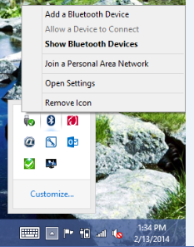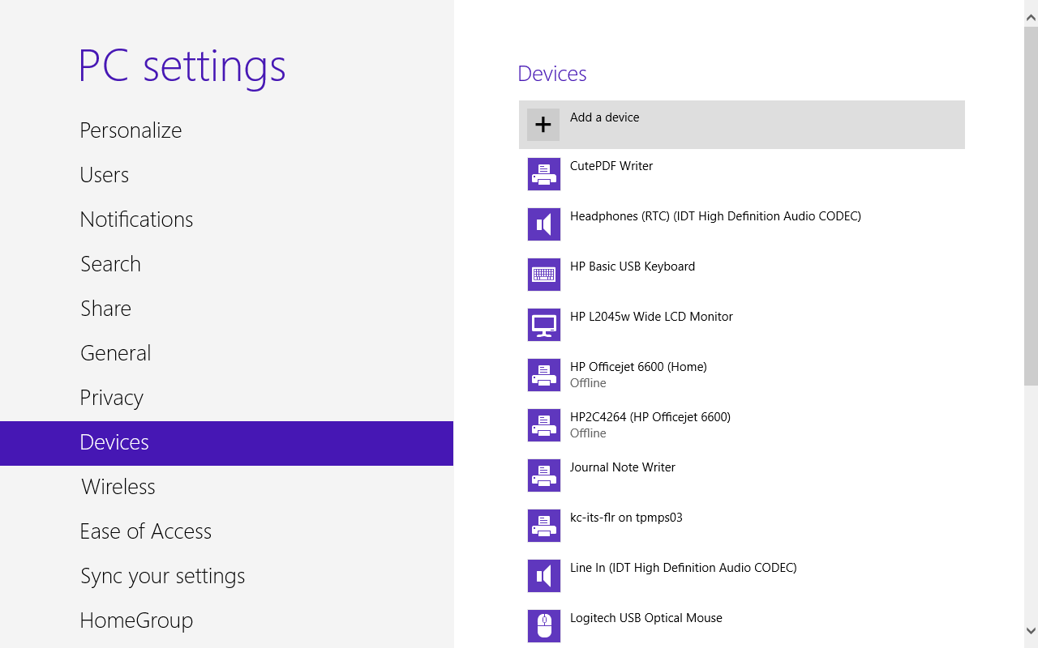The first step is to add the quadrotor to the list of Bluetooth connections available to the laptop. With the quadrotor powered on, select ‘Add a Bluetooth Device’ as shown in Figure 2 to go to device settings which is pictured in Figure 3.

Figure 2: Add a Bluetooth Device

Figure 3: Device Settings

Select ‘Quadrotor’ from the list. It will prompt for the passcode for the device which by default is 1234. This screen is shown in Figure 4. Pressing ‘Next’ will complete the process of pairing the device to the laptop.

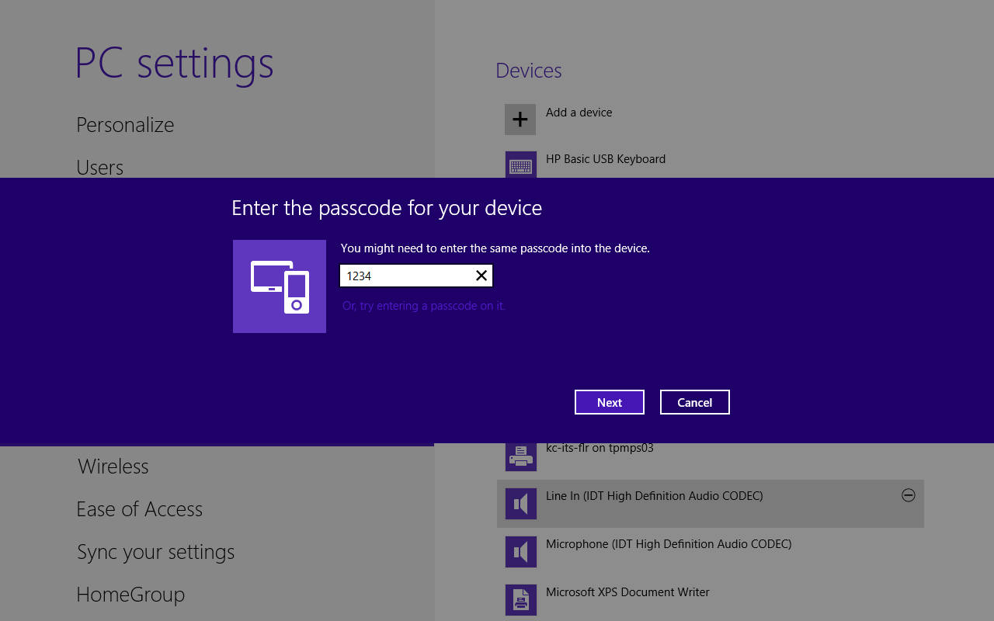The final step is to find what COM port on the laptop the connection has. To do this click on the ‘Open Settings’ option of the Bluetooth shortcut on the toolbar as shown in Figure 5. In the settings window, select the ‘COM Ports’ tab, if the quadrotor is not already there select Add then Outgoing then select Quadrotor as the device that will use the connection. This sequence is shown in Figure 6. If it did populate automatically make note of what port is listed as outgoing. That port will be used in the Quadrotor Control application to send and receive data from the quadrotor.

Figure : Device Add

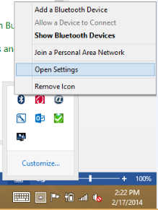

Figure : Bluetooth Settings

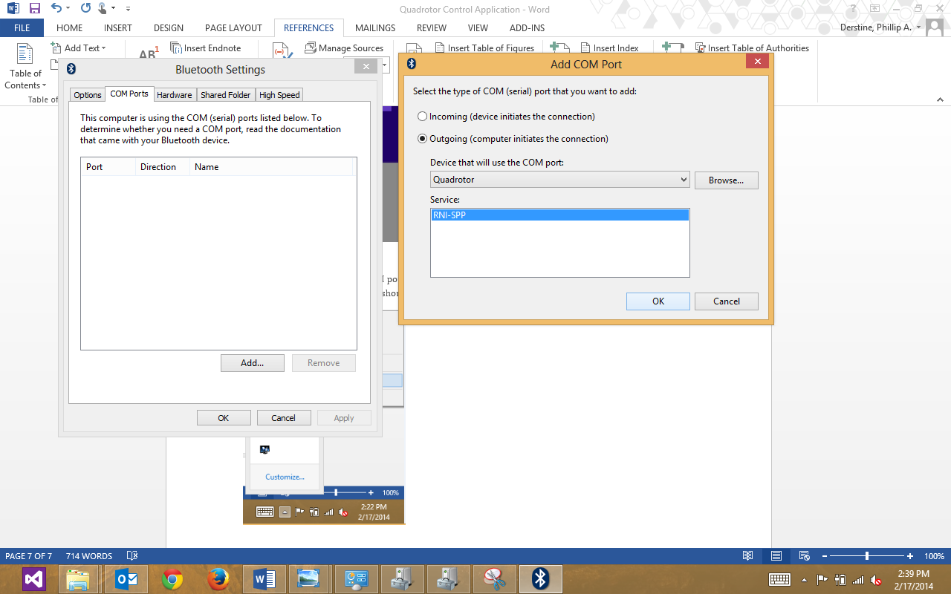

Figure : Adding a COM port

The final step is to make sure the settings are correct for the outgoing COM port. By going to Device Manager in the Control Panel, opening the Ports section the port the quadrotor is connected should be listed. Right click on the port and select properties. Make sure the port settings match those shown in Figure 7 as they are what the quadrotor is expecting.

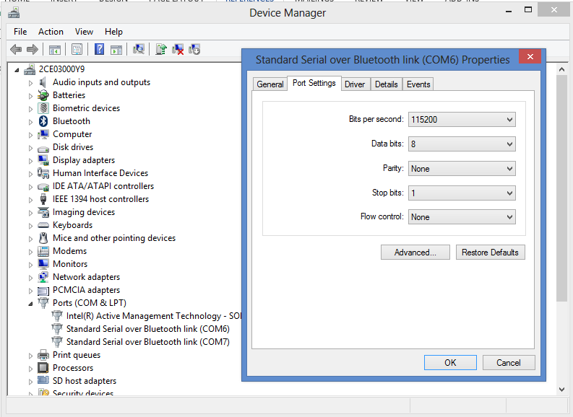

Figure : Port Settings